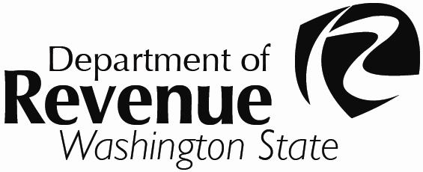 |  |  |  | Application for Exemption of Farm Machinery and Equipment to be
Filed with |  |  |  |  |  |  |  |  |  |  |  |  |  | County Personal Property Affidavit
Under RCW 84.36.630, all qualifying farm machinery and equipment is exempt from the state property tax. Qualifying equipment is still subject to local property taxes and must continue to be reported on the county personal property listing form. Qualifying machinery and equipment must be; (1) owned by an active farmer, (i.e. someone who is in the business of farming), and (2) the equipment must have been used in the business of farming during each year the claim for exemption is made. Additionally, equipment claimed for exemption must also have been used exclusively in growing, raising, or producing agricultural products. Equipment not qualifying includes; (1) equipment used in growing, raising, or producing agricultural products for a person’s own consumption, (2) equipment used in the selling of animals from stockyards, slaughter houses, and packing houses, and (3) equipment used in cultivating or raising timber. The claim for exemption must be submitted by April 30 each year with the personal property listing form to the County Assessor where the personal property is located. For a listing of qualifying farming activities refer to RCW 82.04.213 and RCW 15.85.020.
Applicant’s Name:
Address: |  |  |  |  |  |  |  |  |  |  |  |  |  |  |  |  |  | County:
City: |  |  |  |  |  |  |  |  |  |  | State: |  |  |  |  |  |  |  | Zip Code:
Date of Application: |  |  |  |  |  |  |  |  |  |  |  |  |  |  | Assessment / Claim Year:
Personal Property Claimed (Must have been used exclusively in farming in year claimed and owned by a “Farmer”)
Property Location Where Farming is Performed:
Personal Property Parcel / Account No:
Listing and Description of Personal Property Claimed for Exemption (If more space is needed, attach a separate listing)
 | Equipment Description |  |  |  |  |  |  |  |  |  |  |  |  |  |  |  | Year of  Acquisition |  |  |  |  | Purchase Price  (less sales tax)

Qualification Questionnaire
Type of Farming: (e.g. dairy, wheat, livestock, etc.)
A “Farmer” owns the personal property claimed for exemption? Yes No
Are you currently engaged in the business of growing, raising, or producing agricultural products? Yes No
Do you farm upon lands you own or that you have a present right of possession? Yes No
Do you grow or produce agricultural products that are for sale? Yes No
Do you consider yourself to be a “farmer” as defined in RCW 82.04.213(3)(a), below? Yes No

“‘Farmer’ means any person engaged in the business of growing, raising, or producing, upon the person's own lands or upon the lands in which the person has a present right of possession, any agricultural product to be sold, and the growing, raising, or producing honeybee products for sale, or providing bee pollination services, by an eligible apiarist. "Farmer" does not include a person growing, raising, or producing such products for the person's own consumption; a person selling any animal or substance obtained therefrom in connection with the person's business of operating a stockyard or a slaughter or packing house; or a person in respect to the business of taking, cultivating, or raising timber.”
Is a personal property listing form filed or attached for the claim year, listing all farm equipment? Yes No

Certification
I certify under penalty of perjury under the laws of the state of Washington that a “farmer” owns the above-described farm machinery and equipment, and it is used exclusively in growing, raising, or producing agricultural products during the calendar year for which the claim for exemption is made. I further certify that the statements made in this application are true and correct.
Date Signature
To ask about the availability of this publication in an alternate format for the visually impaired, please call 360-705-6705.
Teletype (TTY) users may use the Washington Relay Service, dial 711. For assistance, contact your local county assessor’s office.
REV 63 0027 (3/31/2025)

