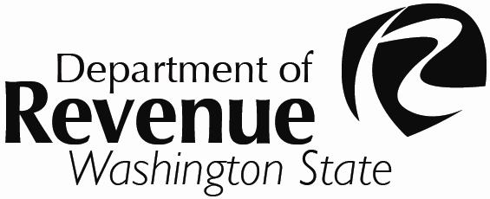
Ordinance / Resolution No.
RCW 84.55.120
WHEREAS, the |  |  |  |  |  |  |  |  |  | of |  |  |  |  |  |  |  |  |  |  |  |  | has met and considered
 |  | (Governing body of the taxing district) |  |  |  |  |  |  |  |  |  |  | (Name of the taxing district)
its budget for the calendar year |  |  |  |  |  |  |  | ; and,
WHEREAS, the districts actual levy amount from the previous year was $ |  |  |  |  |  |  |  |  |  |  |  |  |  |  |  |  |  |  |  |  |  |  |  |  | ; and,
 |  |  |  |  |  |  |  |  |  |  |  |  |  |  |  |  |  |  |  | (Previous year’s levy amount)
WHEREAS, the population of this district is more than or less than 10,000; and now, therefore,
 |  |  |  |  |  |  |  | (Check one)
BE IT RESOLVED by the governing body of the taxing district that an increase in the regular property tax levy
is hereby authorized for the levy to be collected in the |  |  |  |  |  |  |  |  |  |  |  |  |  |  |  |  | tax year.
 |  |  |  |  |  |  |  |  |  |  |  | (Year of collection)
The dollar amount of the increase over the actual levy amount from the previous year shall be $
which is a percentage increase of |  |  |  |  |  |  |  |  | % from the previous year. This increase is exclusive of
 |  |  |  |  | (Percentage increase)
additional revenue resulting from new construction, improvements to property, newly constructed wind turbines, solar, biomass, and geothermal facilities, and any increase in the value of state assessed property, any annexations that have occurred and refunds made.
Adopted this |  |  |  | day of |  |  |  |  |  |  |  |  |  | , |  |  |  |  | .
If additional signatures are necessary, please attach additional page.
This form or its equivalent must be submitted to your county assessor prior to their calculation of the property tax levies. A certified budget/levy request, separate from this form is to be filed with the County Legislative Authority no later than November 30th. As required by RCW 84.52.020, that filing certifies the total amount to be levied by the regular property tax levy. The Department of Revenue provides the “Levy Certification” form (REV 64 0100) for this purpose. The form can be found at: http://dor.wa.gov/docs/forms/PropTx/Forms/LevyCertf.doc.
To ask about the availability of this publication in an alternate format, please call (360)705-675. Teletype (TTY) users may use the Washington Relay Service by calling 711. For tax assistance, call (360) 534-1400.
REV 64 0101e (w) (12/9/14)

